<https://www.postman.com/downloads/>

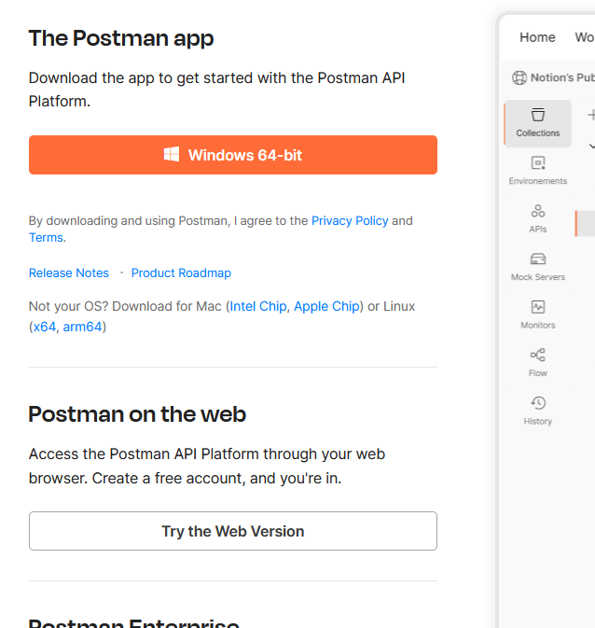

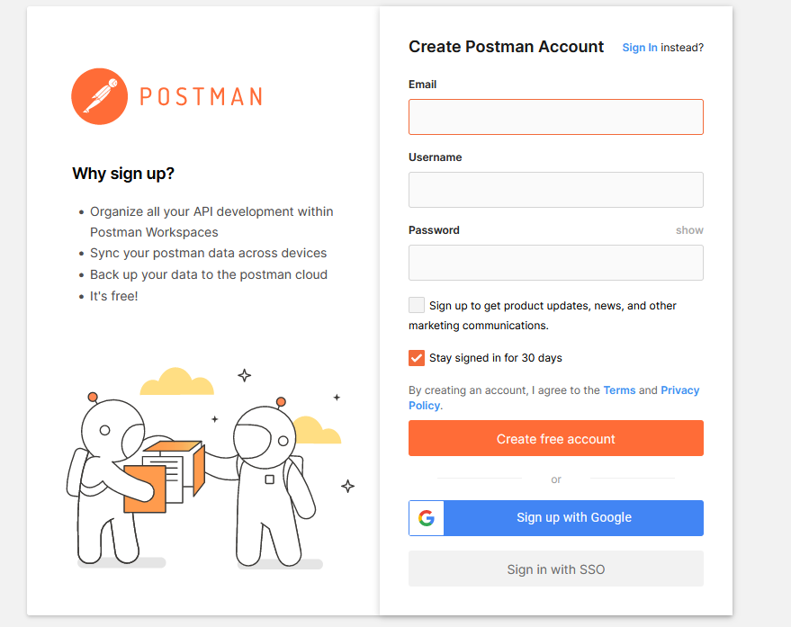

<https://www.postman.com/cs-demo/workspace/public-rest-apis/collection/8854915-454a2dc7-dcbe-41cf-9bfa-da544fcd93a2>

fork the collection

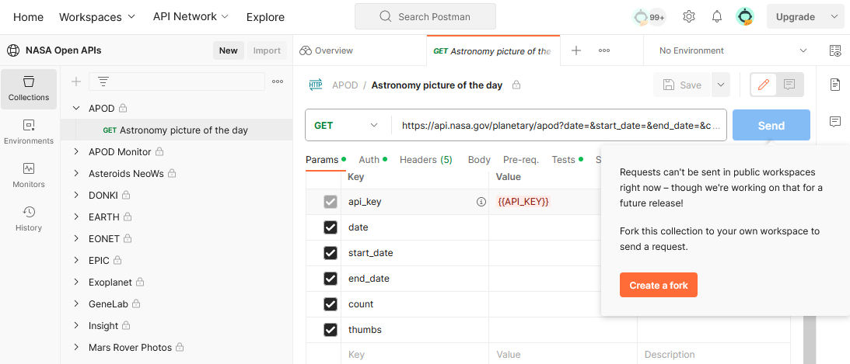

<https://www.postman.com/miguelolave/workspace/nasa-open-apis/request/3419756-78100262-1086-43d3-88e2-f40332bb0e92>